Pandas Data Analysis Report
Objective
The objective of this task is to demonstrate data analysis skills using Pandas. The steps include loading a dataset, inspecting it, handling missing values, cleaning incorrect data, filtering, grouping & aggregation, and deriving insights.
Dataset Used
- File Name : students.csv
- Columns : Name, Department, Age, Marks, Attendance
- Description : Student details including department, age, marks and attendance.
1. CSV Loading & Inspection
The dataset was loaded using Pandas and the first five rows were displayed to understand the data.
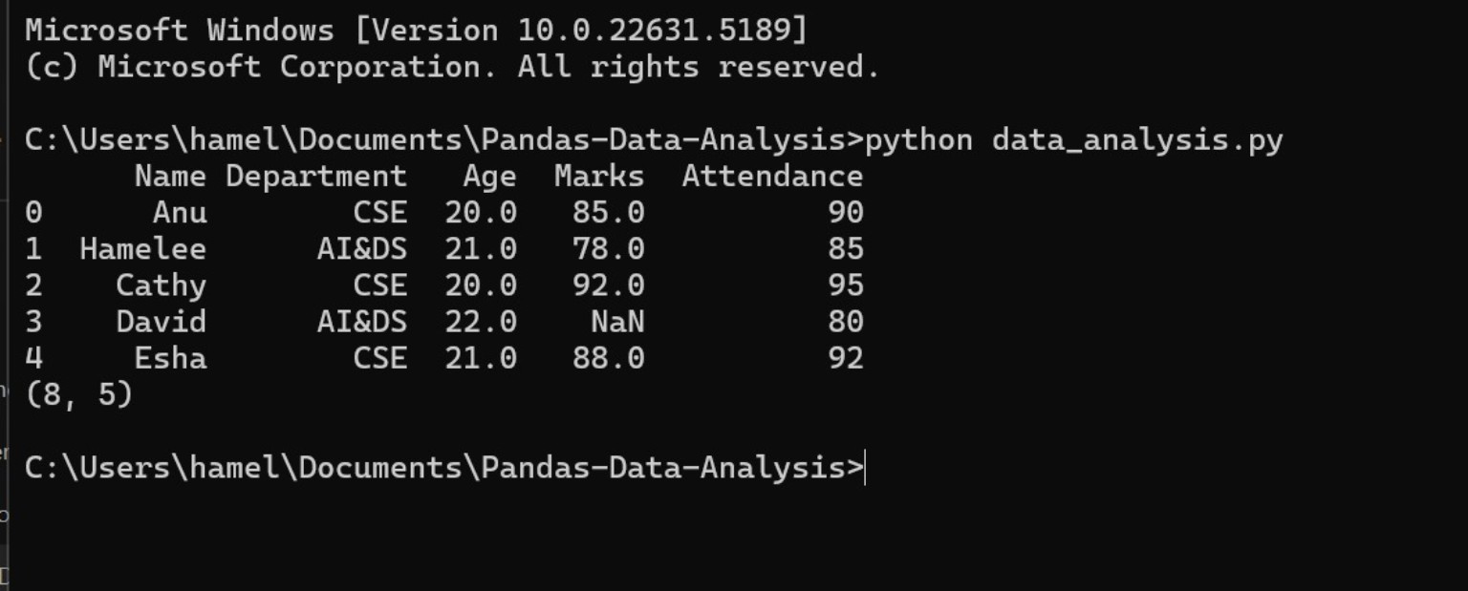
Figure 1: CSV Loading & Inspection
2. Check Missing Values
Checked for missing values in each column.
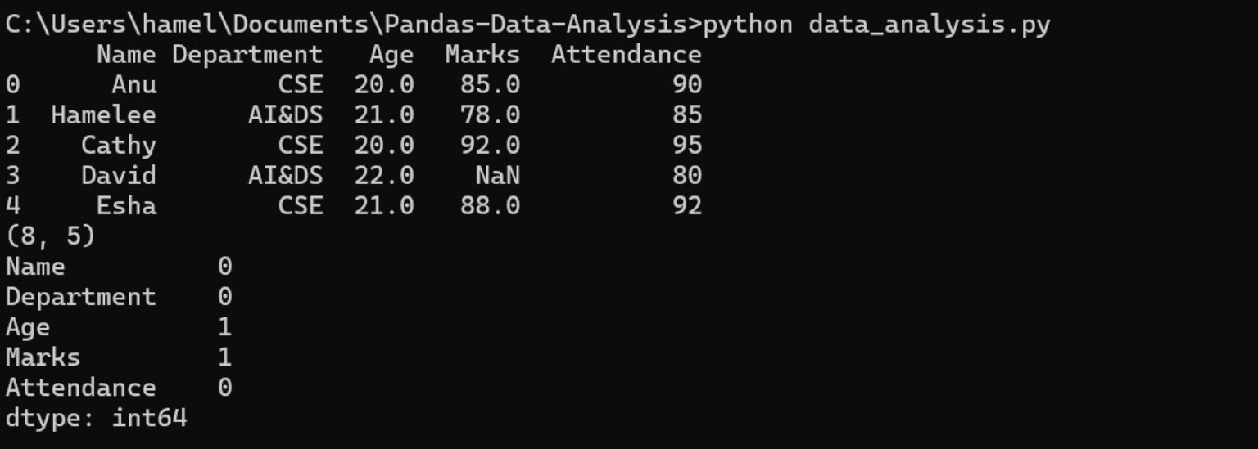
Figure 2: Check Missing Values
3. Cleaned Dataset (After Handling Missing Values)
Missing values in 'Age' and 'Marks' were filled with the column mean.
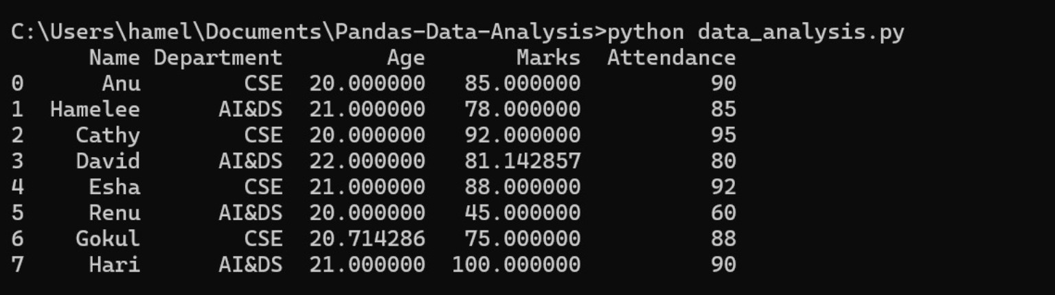
Figure 3: Cleaned Dataset (After Handling Missing Values)
4. Incorrect Data Cleaned (Marks > 100 set to 100)
Incorrect value 105 in the Marks column was corrected to 100.
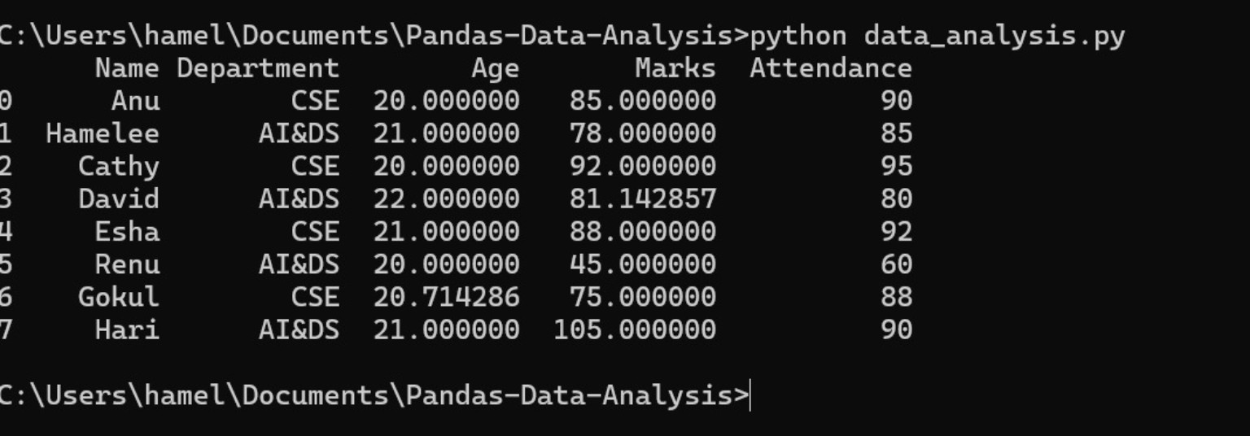
Figure 4: Incorrect Data Cleaned (Marks > 100 set to 100)
5. Filtering (Students with Marks > 80)
Filtered students who scored more than 80 marks.
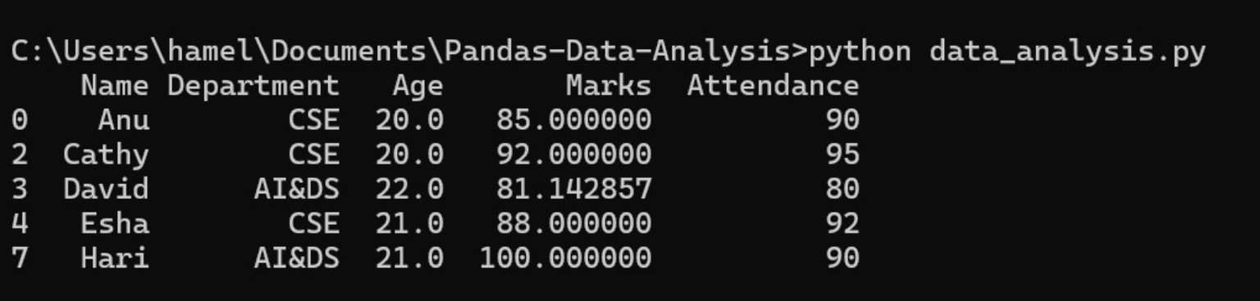
Figure 5: Filtering (Students with Marks > 80)
6. Grouping & Aggregation (Department-wise Marks)
Calculated mean, max and min marks for each department.
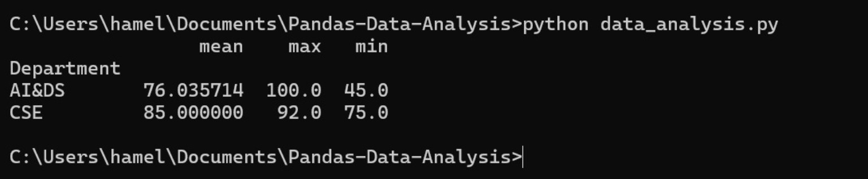
Figure 6: Grouping & Aggregation (Department-wise Marks)
7. Attendance Analysis (Department-wise Average Attendance)
Calculated the average attendance for each department.
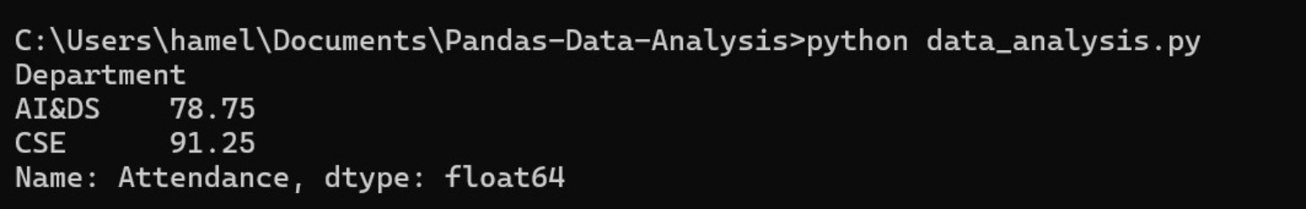
Figure 7: Attendance Analysis (Department-wise Average Attendance)
Insight Summary
- The dataset contains 8 student records and 5 columns.
- Age and Marks had missing values, which were filled using column averages.
- An incorrect Marks value of 105 was corrected to 100.
- Students scoring above 80 were successfully filtered.
- CSE has a higher average Marks (85.00) than AI&DS (76.04).
- CSE has a higher average Attendance (91.25) than AI&DS (78.75).
Conclusion
The analysis demonstrates a complete beginner-level Pandas workflow: loading, inspecting, cleaning, filtering, grouping, aggregation and interpreting a student dataset.

